Year 7 English – Reflecting on the oral presentation
Here is an opportunity to reflect on your oral presentation as well as reading and studying THE BONE SPARROW by Zana Fraillon. Please write honestly and don’t forget to write in full sentences. 
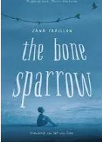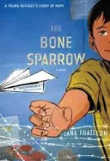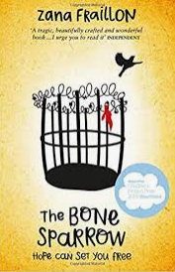
- Did you enjoy reading and studying the novel THE BONE SPARROW? Did you enjoy reading it aloud in class? I found the book very interesting and detailed. I don’t remember reading aloud so I don’t have an opinion

- What are at least two things you learned by reading this book? E.g. new words, specific themes in the book, the resilience of the two main characters, figurative language (metaphors, similes, personifications), life in a detention centre, the way the writer described things

I learnt how life in a detention centre might be like with the two types of guards (harvey and beaver)

- Did you enjoy writing and presenting a speech on the book?
I was very nervous presenting and speaking in front of the class but writing the speech wasn’t so bad

- What was one thing you did well? E.g. writing and preparing my speech, delivering my speech to the class, acting out one of the characters, engaging the audience, practicing my speech at home, finding quotes from the book that I used in my speech,
Having the Shakespeare duck accent

- What was one thing you didn’t do so well? E.g. engaging the class, speaking at an appropriate volume, using my voice effectively, practicing my speech at home, looking at the audience, using the book to help me, not using the full time properly
I wasn’t that loud and clear

- What was at least one comment the teacher made about your speech? What about your peer assessor? That I needed to practice more at home

- What was it like being an audience member throughout the speeches? Did you find them interesting, boring, long, enjoyable?
Some were very short but others were long and hard to concentrate

- Did you enjoy the peer assessing?
Not particularly since I didn’t want to be too harsh

- In the future, what would you do differently when an approaching a task like this?
Practice more at home

- Did you enjoy doing this CAT?

